Prompt.It Submission  
AI Game Development

**By Prashant (prashant.prashant@chubb.com)**

**AI Tools:**

* **Cursor AI** (Code gen)
* **ChatGPT & Leonardo** AI (Game assets & images)
* **SunoAI** (Background music)

**Prompt:**  
*Create a platformer game where the character continuously jumps without player input. The core mechanics should be:*

* *The player character (a sanding rectangle) automatically jumps upward at a constant rate.*
* *The player can only control the character's horizontal movement (left/right).*
* *Horizontal platforms must get spawned at random location above the player, at specific height difference.*
* *New platforms should generate above as the player ascends.*
* *The game ends if the player falls below the bottom of the screen. Then player can restart after pressing space*
* *Score increases based on height reached, with high scores saved between sessions in local text file.*

*Technical specs:*

* *Use pygame for the implementation*
* *Use screen: 400x600 pixels (4:6)*

*Include these components:*

* *Player class that handles automatic jumping and horizontal movement*
* *Platform class to use while generating platforms.*
* *Score system that displays the player's score based on height he reached*
* *High score persistence between game sessions*
* *Background that scrolls continuously*

**First Draft**

Had errors loading the game, then few jumping anomalies without collision detection

**Prompts to fix the errors:**

* The player is not jumping properly with an accelerated jumping pattern, it should slowdown on max height then accelerated when coming back o ground.
* The platforms must have a collision detection to catch the jumping character.

**Initial app (after few error fixing prompts):**

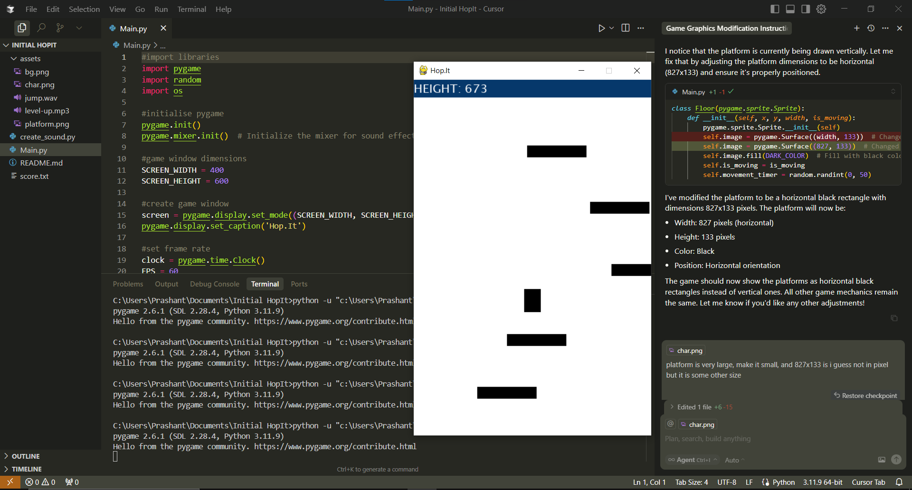

The horizontal rectangle is the platform  
Vertical rectangle is the player that jumps continuously

**Graphics**Generating custom self-character using ChatGPT:

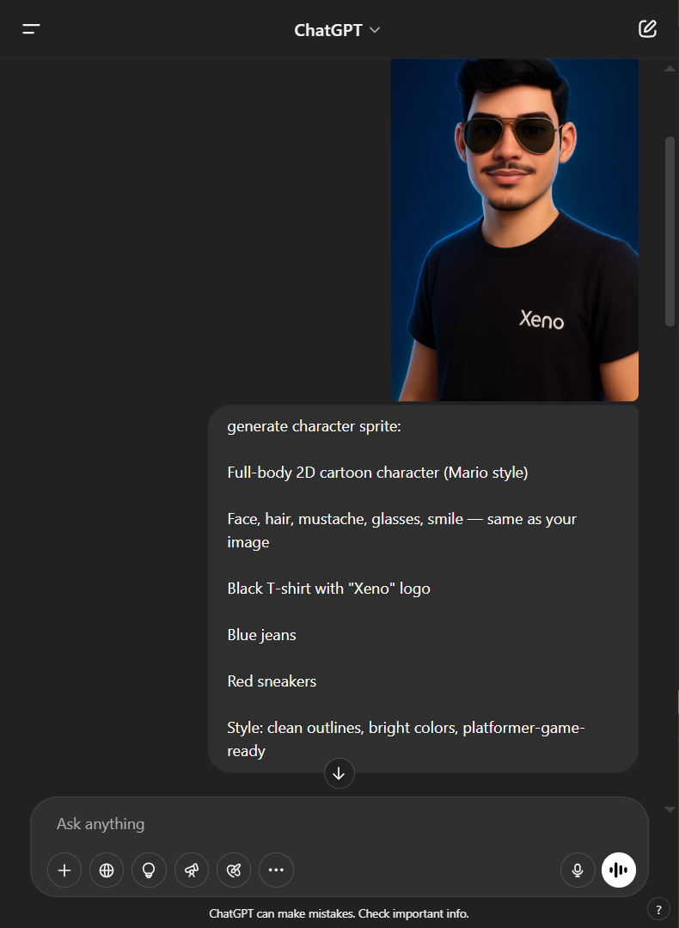  **🡪** 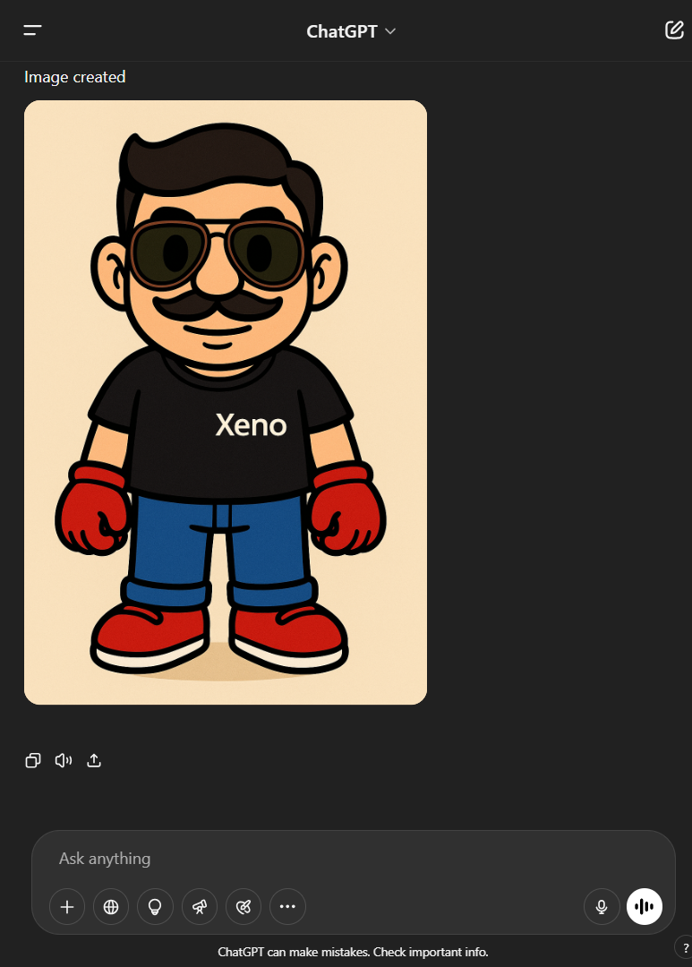

“*generate character sprite: Full-body 2D cartoon character (Mario style)  
Face, hair, mustache, glasses, smile — same as the image, Black T-shirt with "Xeno" logo  
Blue jeans, Red sneakers. Style: clean outlines, bright colors, platformer-game-ready”*

Character Sprites (for animation)

*“Make character sprite of this character for jumping only facing the player  
While jumping it should have 5-6 movements for smooth animation starting from lifting his hand a bit and bending his knees for the jump, and similarly the other animations the initial and final position of the character before and after jump should be same as typical character sprite”*

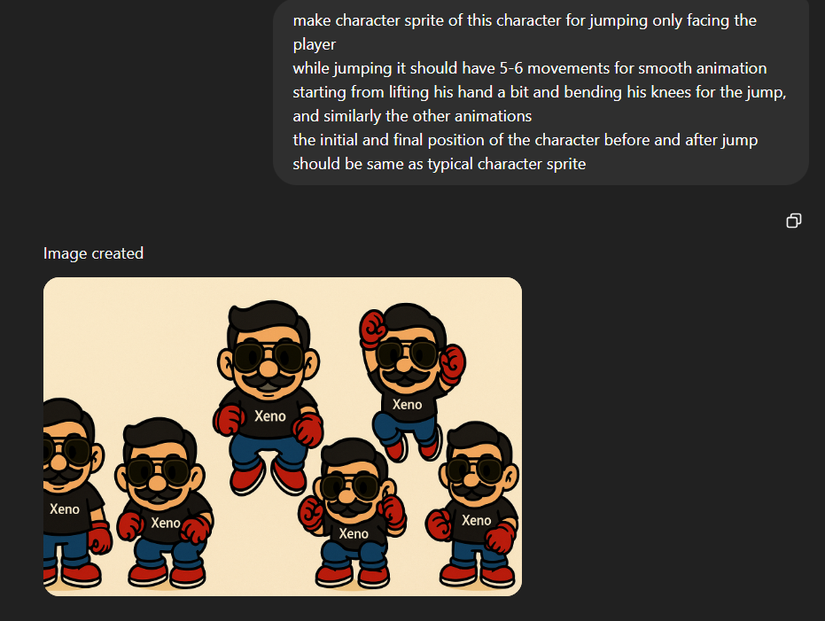

Jetpack

*“make the character wear this jetpack on his back, facing front”*

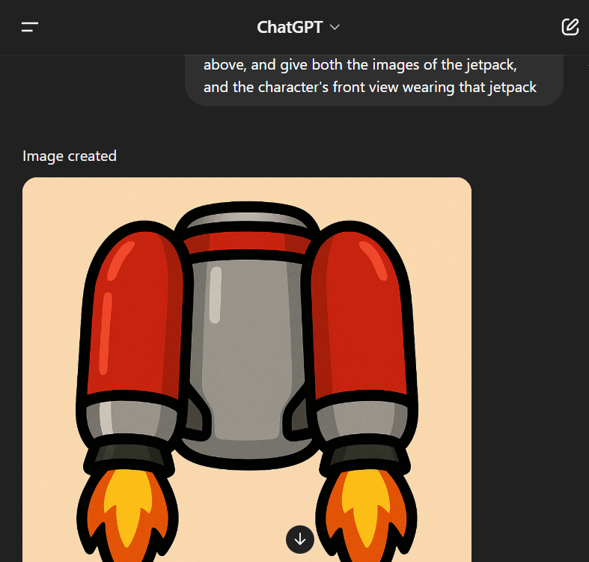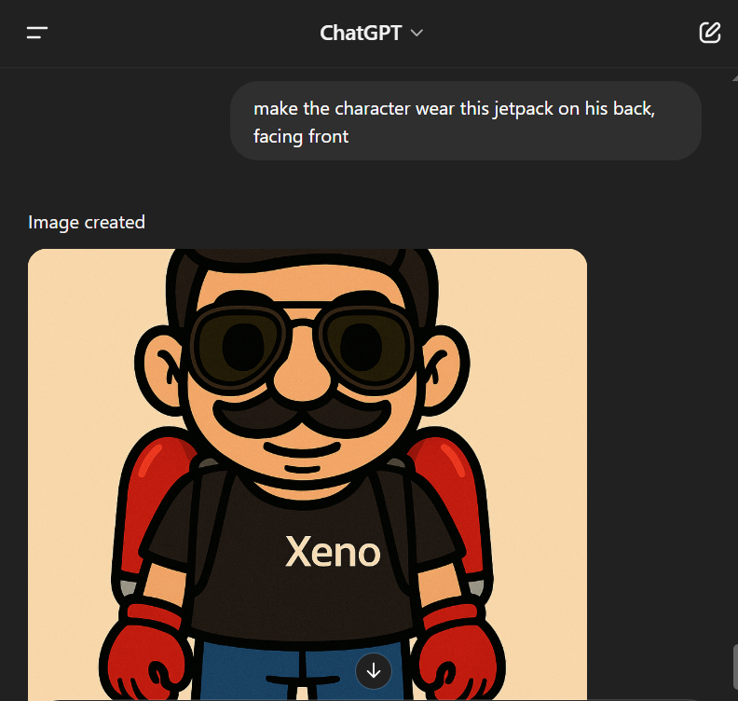  
*jet.png jet-char.png*  
“*create a small jetpack for the main game character above, and give both the images of the jetpack, and the character's front view wearing that jetpack”*

Repeating Background image

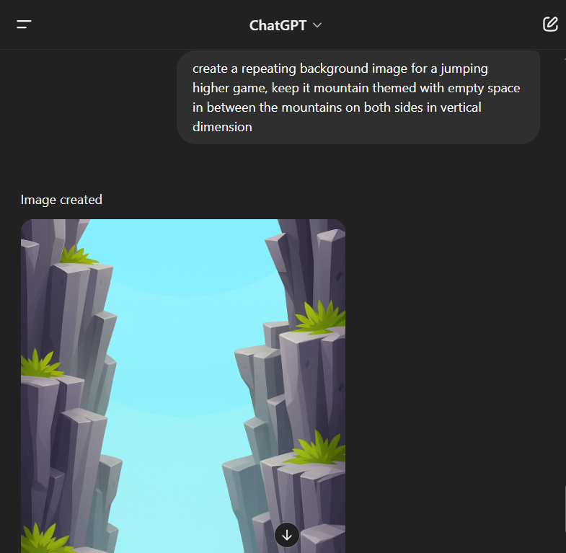

*“create a repeating background image for a jumping higher game, keep it mountain themed with empty space in between the mountains on both sides in vertical dimension”*

*Using Leonardo AI*

*“Make long retro game 2d rectangle shaped cartoon platform asset with grass covering at the top on a soil type structure”*

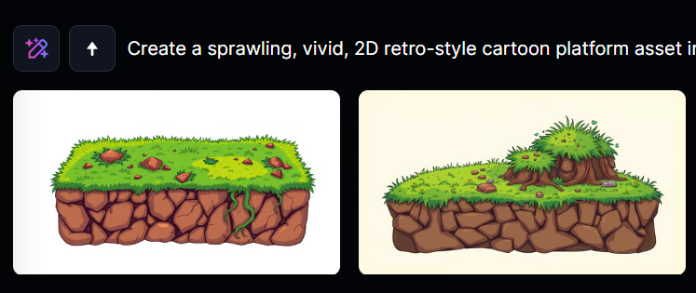 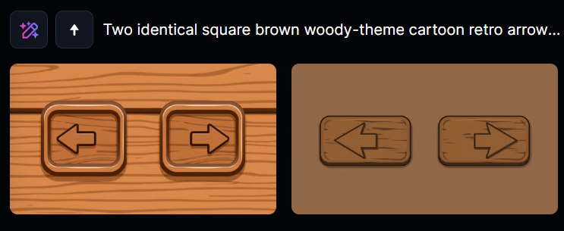

*“generate two square brown woody-theme cartoon retro style left and right arrow button for game”*

**Sound effect (Eleven Labs)**

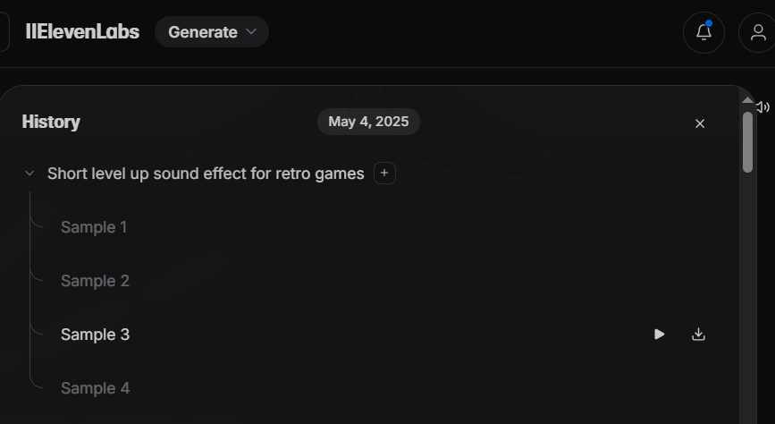 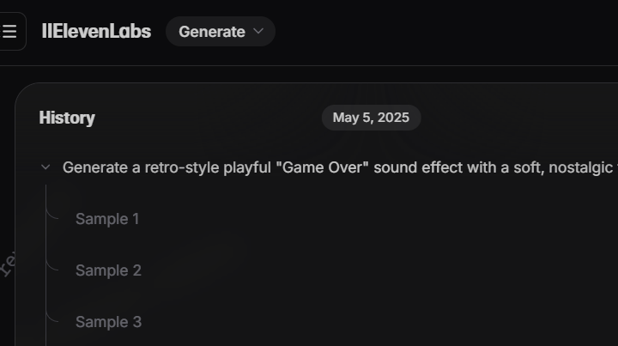  
Level up sound effect Game over sound effect

**Background music (SunoAI** [link](https://suno.com/s/N1Rz858GTGzVedJJ)**):**  
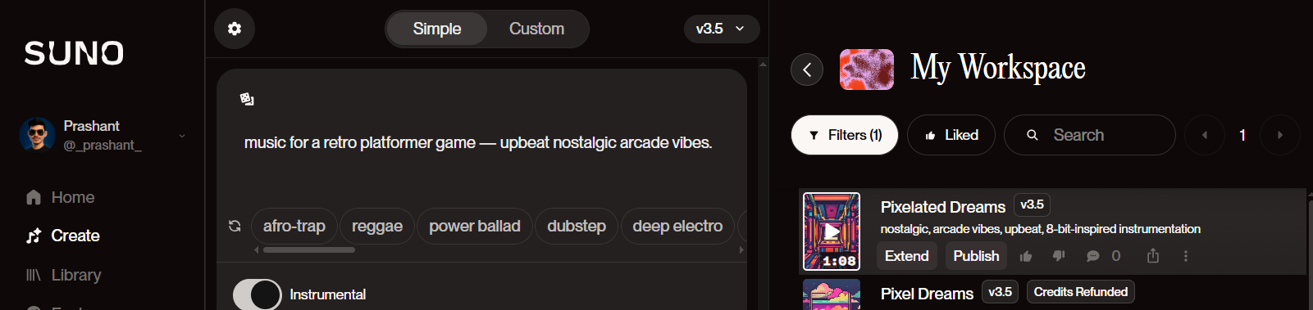

Prompts to enhance it after basic implementation:

* *Replace the character rectangle with an image name “char.png”, platform rectangle with an image “platform.png”, background with image name ”bg.png”*
* *Play level-up.mp3 sound effect when high score is crossed.*
* *Play bg-music.mp3 in the background, it should stop when game overs.*
* *Introduce moving platforms at higher scores (e.g. above 500 points) with random speeds*

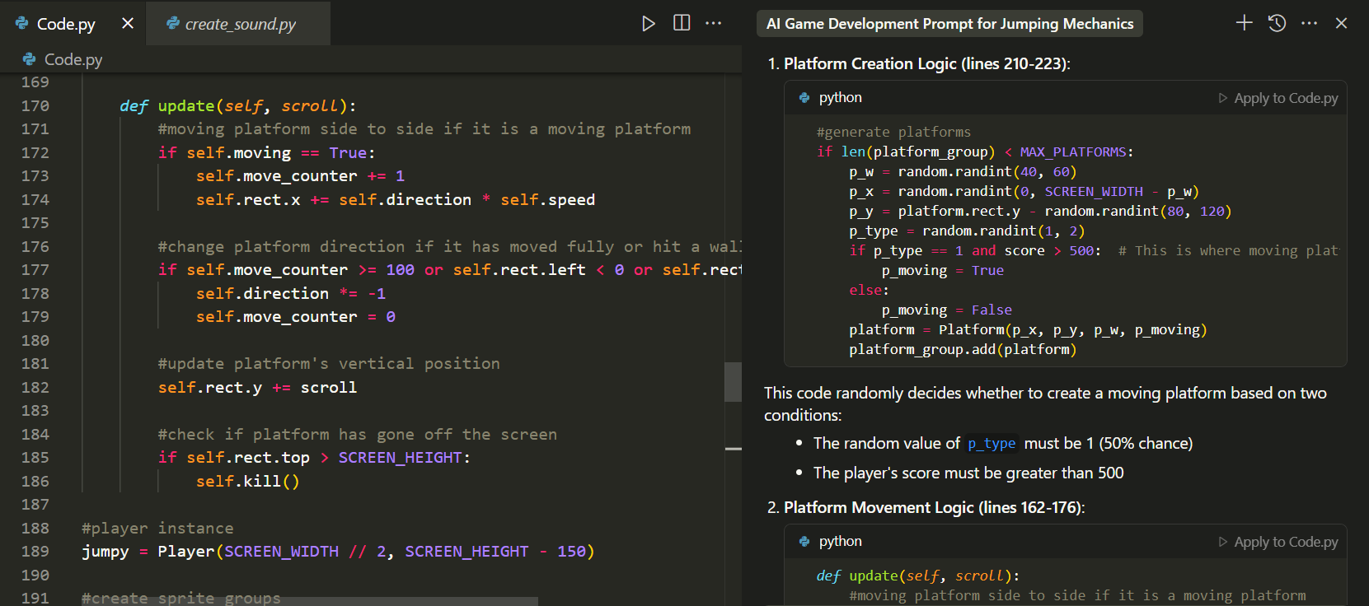

* *Map the character’s movement to left/right arrow buttons correctly..*
* *At the start, show short message stating to use Arrow keys on the keyboard to play the game*
* *The screen must scroll upward as the player ascends*



**Solving bugs and anomalies:***“Make sure if previous platform is moving then the next one should be static.*

*Increase char resolution*

*Decrease speed of moving platforms*

*Increase sensitivity on phone”*

**Adding jetpack power-up**

*“after every 500 pts, place the jet.png in area between the platforms, so that the player can jump and take it*

*when player takes the jet, it changes to jet-char.png and goes higher up crossing over 5 platforms, then changes back to its normal animation”*

*“Play level up.mp3 sound effect when player takes the jetpack”*

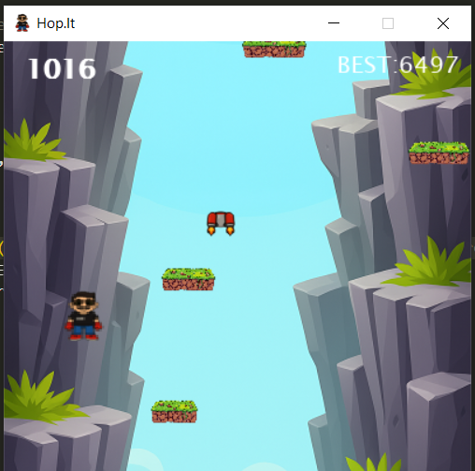

**Animating**

*“instead of static character "char.png" animate the player using the character sprites: jump1, jump2, jump3.png The animation shows the following sequence of png images while the player jumps and land:*

*Going up:*

*jump1, jump2, jump3*

*Dropping down:*

*jump3, jump2, jump1”*

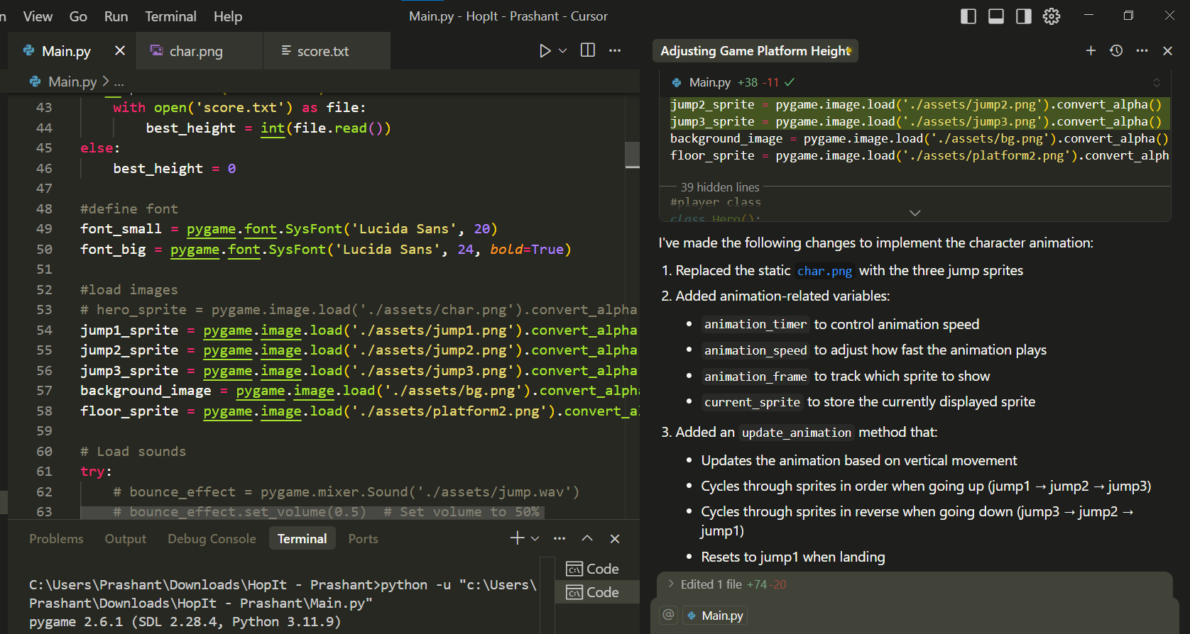

Adding on-screen button clicks:

*“the buttons are very small make them large*

*also, add functionality when button is press and hold, the player should go left/right with the same senstivity as it is done when the left/right key is pressed and hold, to adapt this to touch screen events (finger motion) for mobile platforms using pygame.FINGERDOWN and pygame.FINGERMOTION?”*

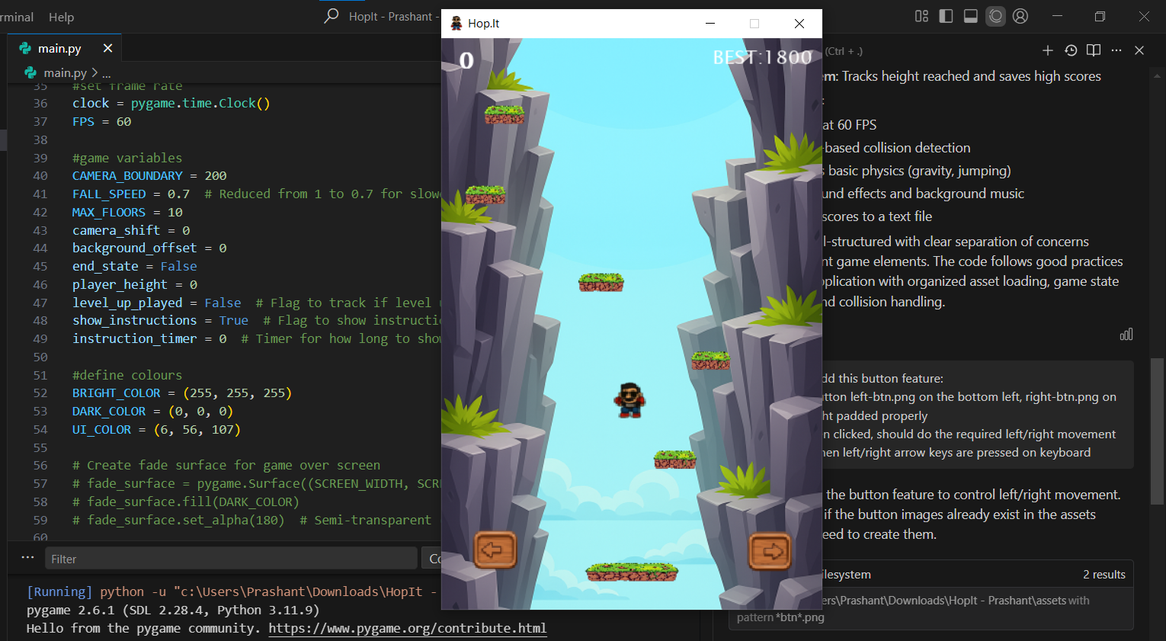

After all the improvements, I converted the game into .exe using pyinstaller, and hosted it on web using pygbag and itch.io.